Service Monitoring – Hystrix, Eureka admin and Spring boot admin
Spring boot and spring cloud are widely used while delivering microservices-based applications. Eventually, it has become a necessity to monitor microservices based on Spring boot applications running on different hosts. There are many tools available to monitor various health stats of these microservices.
In this spring cloud tutorial, we will learn to use three such monitoring tools i.e. Hystrix dashboard, Eureka admin dashboard and Spring boot admin dashboard.
Table of Contents

1. Overview
2. Technology stack
3. Employee Service
4. API-Gateway application
5. Hystrix dashboard view
6. Eureka admin dashboard view
7. Spring boot admin dashboard view

1. Overview
In this demo, we will create three applications.
- Employee Service – This microservice application is responsible to fetch data of Employees.
- Api-Gateway – This application is to provide common gateway while accessing different microservices. In the following example it will act as a gateway to Employee Service above.
- Eureka Server – This microservice application will provide service discovery and registration of above microservices.
This demo has been created around Netflix Eureka to centrally manage and monitor registered applications. As you may already know that Netflix Eureka server is for building service registry server and associated Eureka clients, which will register themselves to lookup other services and communicate through REST apis.

3. Employee Service
- Create a Spring boot project from Spring boot initializer/Spring tool suite with dependencies Eureka Discovery, Actuator, Web, Rest repositories.
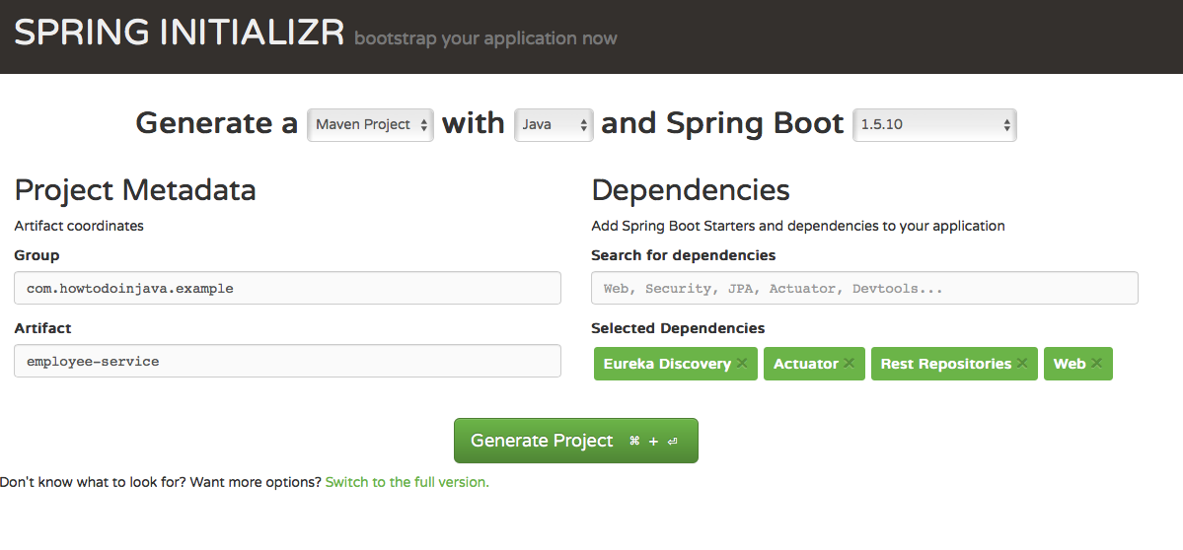
- The main application class EmployeeServiceApplication to start the Spring boot application.
EmployeeServiceApplication.java
package com.howtodoinjava.example.employee;
import org.springframework.boot.SpringApplication;
import org.springframework.boot.autoconfigure.SpringBootApplication;
import org.springframework.cloud.netflix.eureka.EnableEurekaClient;

@SpringBootApplication
@EnableEurekaClient
public class EmployeeServiceApplication {

public static void main(String[] args)
{
SpringApplication.run(EmployeeServiceApplication.class, args);
}
}
- @EnableEurekaClient – This annotation register this service as an Eureka client in Eureka Server application created below.
- Create a Rest controller class [EmployeeServiceController] to expose Employee data.
EmployeeServiceController.java
package com.howtodoinjava.example.employee.controller;

import java.util.HashMap;
import java.util.Map;

import org.springframework.web.bind.annotation.PathVariable;
import org.springframework.web.bind.annotation.RequestMapping;
import org.springframework.web.bind.annotation.RequestMethod;
import org.springframework.web.bind.annotation.RestController;

import com.howtodoinjava.example.employee.beans.Employee;

@RestController
public class EmployeeServiceController {

private static final Map<Integer, Employee> employeeData = new HashMap<Integer,Employee() {

private static final long serialVersionUID = -3970206781360313502L;
{
put(111,new Employee(111,"Employee1"));
put(222,new Employee(222,"Employee2"));
}
};

@RequestMapping(value = "/findEmployeeDetails/{employeeId}", method = RequestMethod.GET)
public Employee getEmployeeDetails(@PathVariable int employeeId) {
System.out.println("Getting Employee details for " + employeeId);

Employee employee = employeeData.get(employeeId);
if (employee == null) {

employee = new Employee(0, "N/A");
}
return employee;
}
}
- Associated Employee Bean class is below.
Employee.java
package com.howtodoinjava.example.employee.beans;

public class Employee {

private String name;
private int id;

@Override
public String toString() {
return "Employee [name=" + name + ", id=" + id + "]";
}
}
- Create application.yml in src/main/resources directory.
application.yml
server:
port: 8011

eureka:
instance:
leaseRenewalIntervalInSeconds: 5
leaseExpirationDurationInSeconds: 2
client:
serviceUrl:
defaultZone: http://localhost:8761/eureka/
healthcheck:
enabled: true
lease:
duration: 5

spring:
application:
name: employee-service

management:
security:
enabled: false

logging:
level:
com.self.sprintboot.learning.employee: DEBUG
- Start this application reachable http://localhost:8011/findEmployeeDetails/111
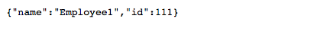

4. API-Gateway with Hystrix
- Create a Spring boot project from Spring boot initializer/Spring tool suite with dependencies Eureka Discovery, Actuator, Web, Hystrix, Hystrix Dashboard, Rest repositories.
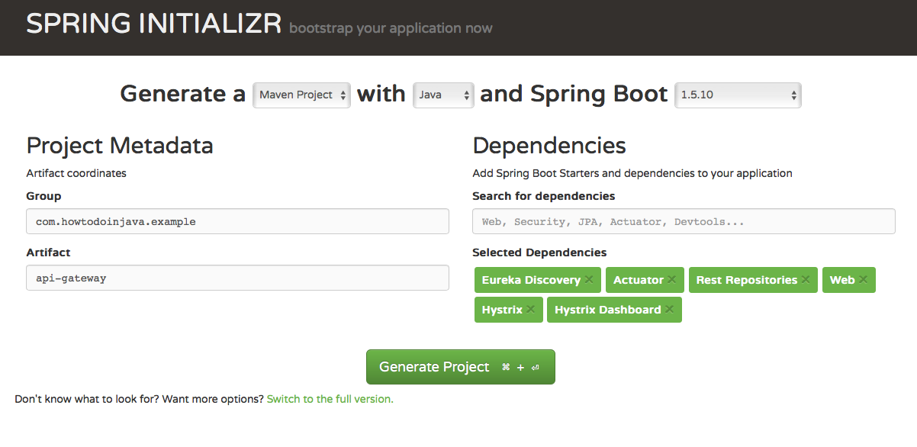
- The main application class ApiGatewayApplication to start Spring boot application.
ApiGatewayApplication.java
package com.howtodoinjava.example.apigateway;

import org.springframework.boot.SpringApplication;
import org.springframework.boot.autoconfigure.SpringBootApplication;
import org.springframework.cloud.client.circuitbreaker.EnableCircuitBreaker;
import org.springframework.cloud.netflix.eureka.EnableEurekaClient;
import org.springframework.cloud.netflix.hystrix.dashboard.EnableHystrixDashboard;

@SpringBootApplication
@EnableEurekaClient
@EnableHystrixDashboard
@EnableCircuitBreaker
public class ApiGatewayApplication {

public static void main(String[] args) {
SpringApplication.run(ApiGatewayApplication.class, args);
}
}
- @EnableHystrixDashBoard – To give dashboard view of Hystrix stream.
@EnableCircuitBreaker – To enable Circuit breaker implementation.
- Create a REST controller class [ EmployeeController ] to expose Employee data.
EmployeeController.java
package com.howtodoinjava.example.apigateway.controller;

import org.springframework.beans.factory.annotation.Autowired;
import org.springframework.cloud.client.loadbalancer.LoadBalanced;
import org.springframework.context.annotation.Bean;
import org.springframework.core.ParameterizedTypeReference;
import org.springframework.http.HttpMethod;
import org.springframework.web.bind.annotation.PathVariable;
import org.springframework.web.bind.annotation.RequestMapping;
import org.springframework.web.bind.annotation.RequestMethod;
import org.springframework.web.bind.annotation.RestController;
import org.springframework.web.client.RestTemplate;

import com.netflix.hystrix.contrib.javanica.annotation.HystrixCommand;

@RestController
public class EmployeeController {

@Autowired
RestTemplate restTemplate;

@RequestMapping(value = "/employeeDetails/{employeeid}", method = RequestMethod.GET)
@HystrixCommand(fallbackMethod = "fallbackMethod")
public String getStudents(@PathVariable int employeeid)
{
System.out.println("Getting Employee details for " + employeeid);

String response = restTemplate.exchange("http://employee-service/findEmployeeDetails/{employeeid}",
HttpMethod.GET, null, new ParameterizedTypeReference<String>() {}, employeeid).getBody();

System.out.println("Response Body " + response);

return "Employee Id - " + employeeid + " [ Employee Details " + response+" ]";
}

public String fallbackMethod(int employeeid){

return "Fallback response:: No employee details available temporarily";
}

@Bean
@LoadBalanced
public RestTemplate restTemplate() {
return new RestTemplate();
}
}
- Create application.yml in src/main/resources directory.
application.yml
server:
port: 8010 #port number

eureka:
instance:
leaseRenewalIntervalInSeconds: 5
leaseExpirationDurationInSeconds: 2
client:
serviceUrl:
defaultZone: http://localhost:8761/eureka/
healthcheck:
enabled: true
lease:
duration: 5

spring:
application:
name: api-gateway

management:
security:
enabled: false

logging:
level:
com.self.sprintboot.learning.apigateway: DEBUG
- Start the application reachable at http://localhost:8010/employeeDetails/111.
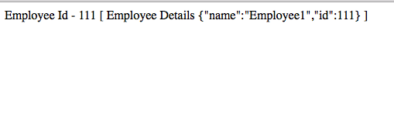

5. Hystrix dashboard view
- To monitor via Hystrix dashboard, open Hystrix dashboard at http://localhost:8010/hystrix.
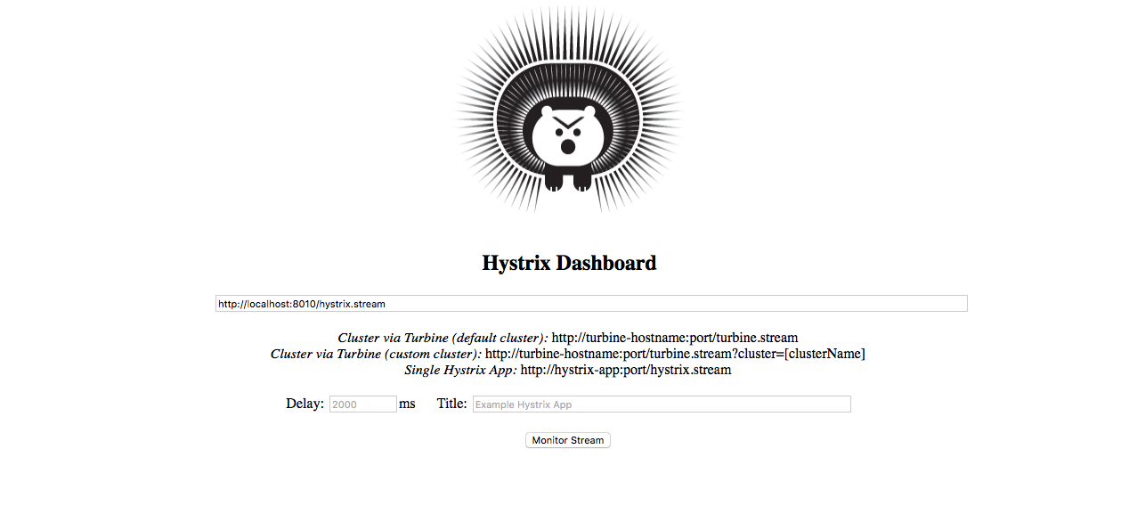
This is the home page where event stream URL needs to be put for monitoring.
- Now view hystrix stream in dashboard – http://localhost:8010/hystrix.stream
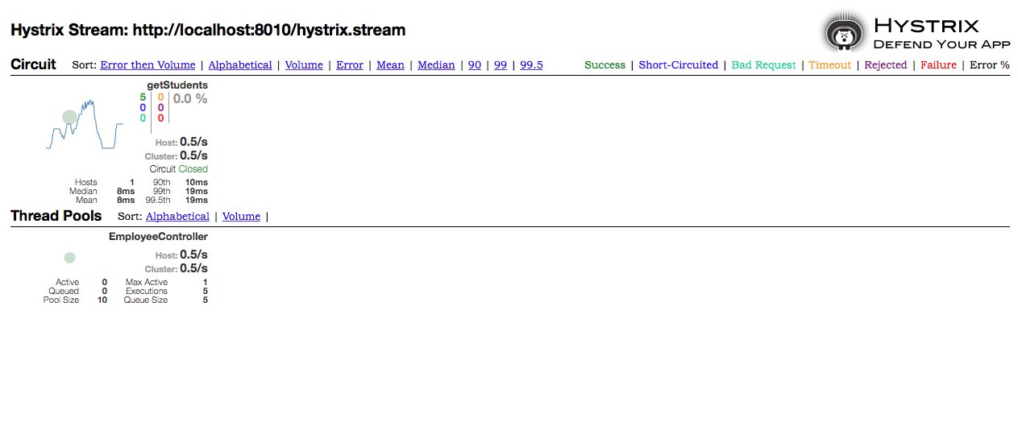
This provides realtime information of all Hystrix commands and thread pools.

6. Eureka admin dashboard view
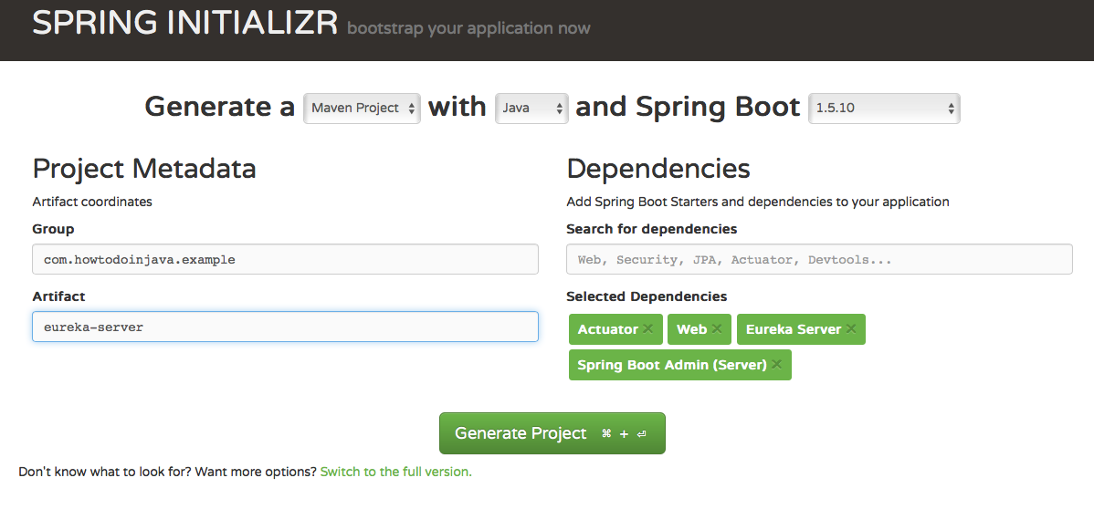
- The main application class EurekaServerApplication to start spring boot application.
EurekaServerApplication.java
package com.howtodoinjava.example.eureka;

import org.springframework.boot.SpringApplication;
import org.springframework.boot.autoconfigure.SpringBootApplication;
import org.springframework.cloud.netflix.eureka.server.EnableEurekaServer;

import de.codecentric.boot.admin.config.EnableAdminServer;

@SpringBootApplication
@EnableEurekaServer
@EnableAdminServer

public class EurekaServerApplication {

public static void main(String[] args) {
SpringApplication.run(EurekaServerApplication.class, args);
}
}
- @EnableEurekaServer– This annotation will make this application to act as Microservice registry and discovery server.
@EnableAdminServer – This annotation provides Spring Boot Admin configuration.
- Create application.yml and bootstrap.yml in src/main/resources directory.
- Add application.yml with given config. Please note that for Spring boot admin server a different context path /admin has been provided for not conflicting with /eureka.
application.yml
server:
port: ${PORT:8761}

eureka:
client:
registryFetchIntervalSeconds: 5
registerWithEureka: false
serviceUrl:
defaultZone: ${DISCOVERY_URL:http://localhost:8761}/eureka/
instance:
leaseRenewalIntervalInSeconds: 10

management:
security:
enabled: false
spring:
boot:
admin:
context-path: /admin #A different context path for Spring boot admin server has been provided avoiding conflict with eureka
- Create bootstrap.yml and give this configuration.
bootstrap.yml
spring:
application:
name: Eureka-Server
cloud:
config:
uri: ${CONFIG_SERVER_URL:http://localhost:8888}
- Start the application. But before that make sure the rest of the client applications mentioned above are started before so as to see all registered applications. This application is reachable at http://localhost:8761.
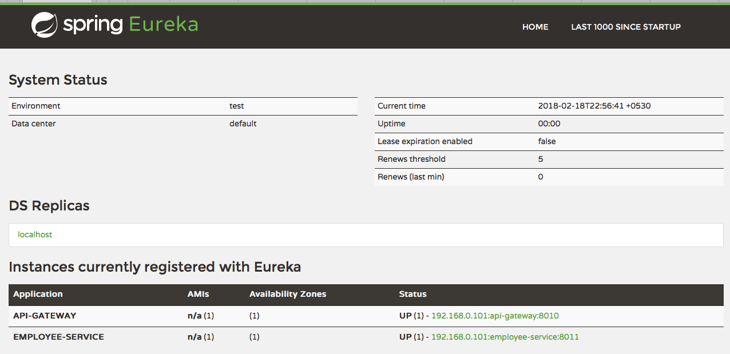

7. Spring boot admin dashboard view
- To monitor via Spring Boot Admin server, invoke this URL running at different context path- http://localhost:8761/admin.
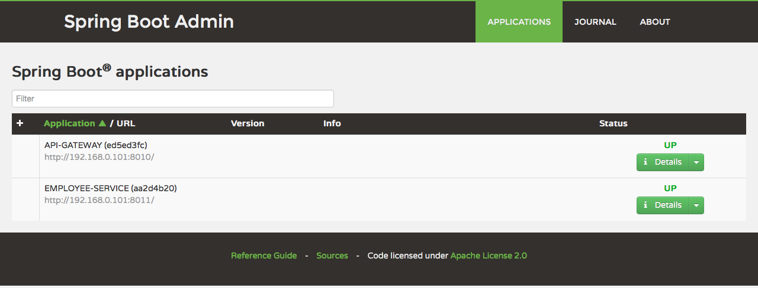
- This admin interface provides application overview, desktop notifications, application health check, log file browsing, JMX Beans, thread heap dump etc. To see individual application health and monitor its metrics, click on the detail button. It will take you to the admin dashboard of individual application.
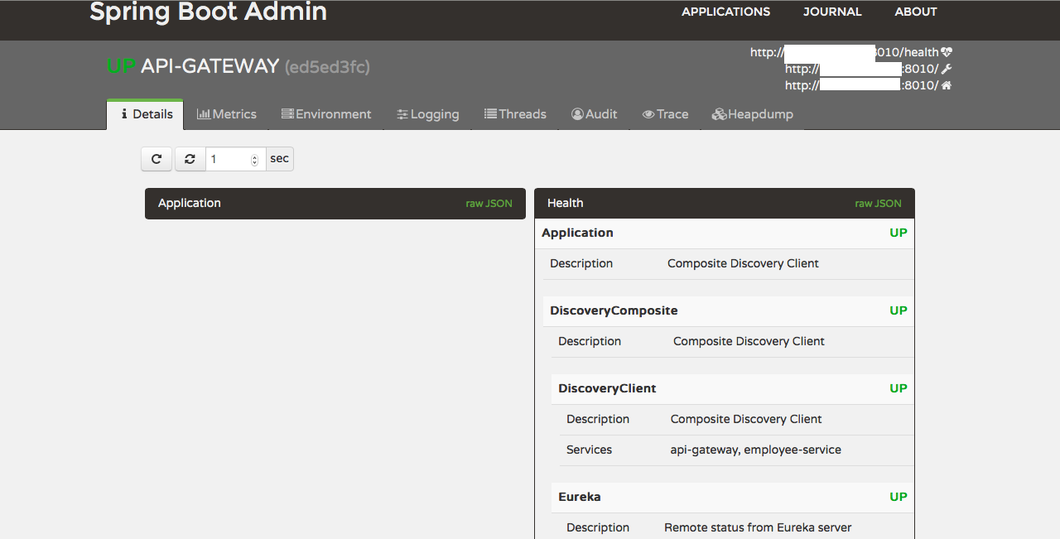
- Using dashboard to manage log levels.
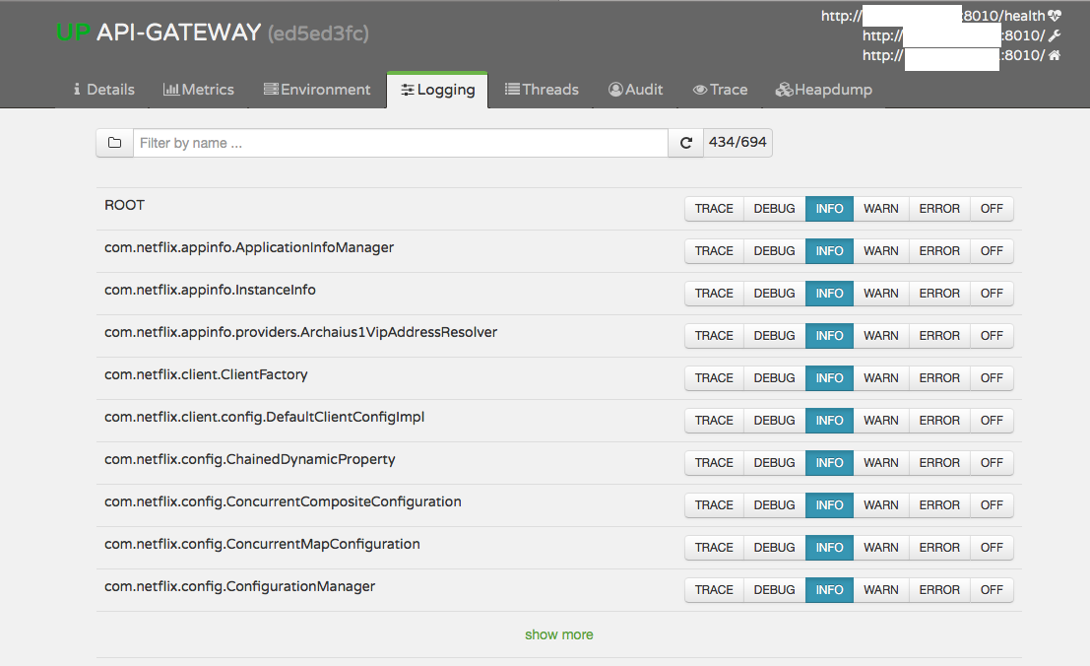
- Using dashboard to manage runtime environment properties.
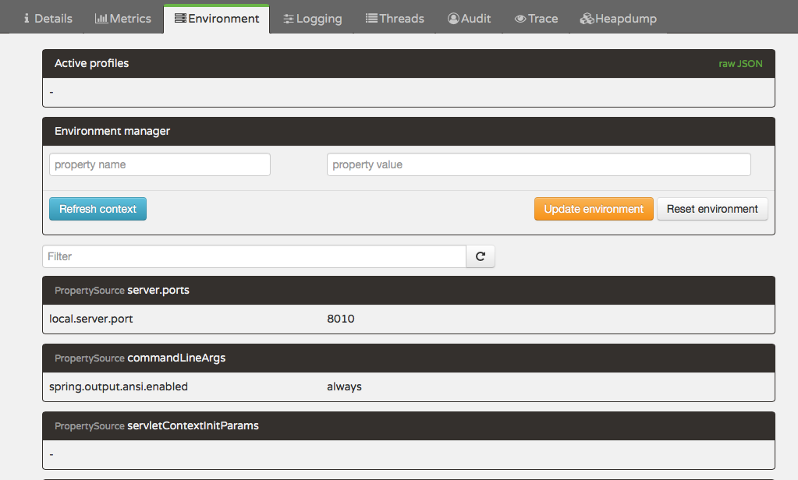
- Also you can use it to view HTTP traces.
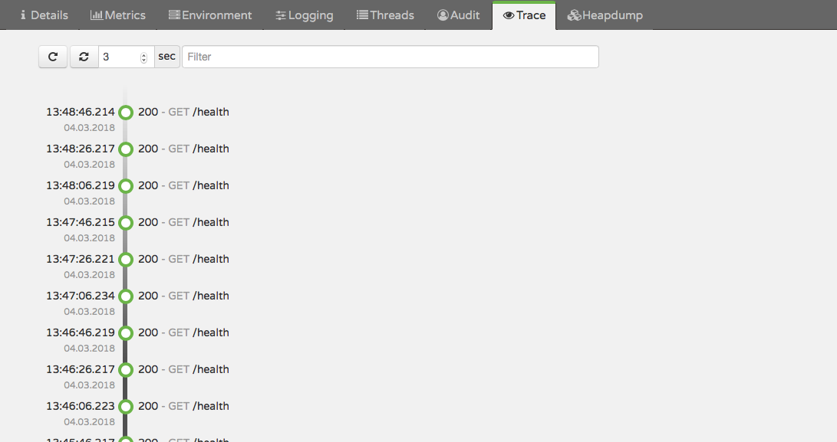
I downloaded all three applications and executed them.
But,
http://localhost:8010/employeeDetails/111
does not give the result. It always call the fallback method.
Please try once and see.
Narayan Khanna

